A Report on the Early Results of LOSPA High-Flexion Total Knee Arthroplasty

Sun General Hospital
Song In-Soo

Introduction

Due to remarkable developments in the design and materials of artificial knee joints in recent years, there has been an increasing interest in the function of prostheses. In particular, various designs of artificial joints that can minimize instability and improve the range of motions (ROM) after knee replacement have been introduced in the market. Many successful cases in the use of high-flexion artificial knee joints, which provide the same or better stability and function compared with typical artificial knee joints have been reported.^{1,2,3,4,5,6,7,8,9,10,11,12)} Using high-flexion artificial knee joint to improve the ROM could reduce the back side radius of the femoral prosthesis, and increase the offset of the posterior condyle enabling the translation and high flexion of the condyle. Nevertheless, this method has a drawback in that it requires additional resection the posterior condyle, which is a retrogression in bone preservation.^{13,14)} Based on the design of the high-flexion artificial knee joint, the amount of posterior condyle bone resection is decided, which ranges from 12.5 mm to 8.0 mm. The Lospa (Corentec Inc.) artificial knee joint was developed and produced by Korean engineers using Korean technology. The design of Lospa is high-flexion-friendly owing to the 10.0 mm posterior condyle bone resection. Considering the non-excessive posterior condyle bone resection and design features, the performance of Lospa is expected to show results similar to other high-flexion artificial joints. Few studies on Lospa have been reported because the product has been introduced in the market only recently. In this study, total knee arthroplasty was performed using Lospa (Corentec Inc.), and the early clinical and radiologic results were compared with those of Scorpio NRG® (Stryker Inc.), which is a proven artificial knee joint.¹⁵⁾

Materials and Methods

A total of 164 cases in 104 patients who underwent total knee arthroplasty using Lospa (Corentec Inc. Group A), and additional 164 cases in 102 patients who had the same procedure using Scorpio NRG® (Stryker Inc. Group B) by a single surgeon in Sun General Hospital between September 2010 and September 2011 were selected for this study. The subjects in both groups were to be followed-up for over one year. The mean age of Group A was 68.6 (54~82), and that of Group B was 70.5 (56~84). The mean follow-up period of Group A was 17 (12~24) months, while that of Group B was 18 (12~24) months. In all cases of both groups, posterior cruciate-substituting total knee arthroplasty was performed using fixed polyethylene components. The causative disease of all the subjects was Kellgrene-Lawrence¹⁶⁾ type Ⅳ degenerative arthritis excluding one rheumatoid arthritis case in each group. The subjects were randomly assigned in sequential manner to both groups. Cases that required constrained prosthesis with the initial diagnosis of knee joint instability, that were diagnosed with infection, and that required revision replacement were excluded from this study. The prosthesis was randomly selected regardless of the severity of arthritis, age, gender, and surgeon’s preference, and the same preoperative indications were applied to both groups.
All subjects underwent total knee arthroplasty by a single surgeon (ISS), and the knee joint flexion contracture and maximum flexion angle were measured preoperatively using a goniometer. After recording the results of preoperative clinical assessment, a standard medial parapatellar approach was conducted. The medial ligament was then released, and the tibia and femur were resected to obtain the same flexion-extension angle. Patella replacement was selectively performed for the arthritis patients, and then, the prosthesis was inserted into the patella, tibia, and femur in sequence using bone cement. In all subjects, the prosthesis for posterior cruciate-substituting total knee arthroplasty was used, and in cases of bone defect in the medial tibia, the defect was filled with a block or cement. In each of the subjects, a drainage tube was inserted, and removed at 2 days postoperatively. The subjects were encouraged to do continuous passive motions and walking. Additionally, exercises for the quadriceps femoris group were conducted.
As radiologic assessments, pre- and postoperative mechanical axis deviation, and changes in the femoro-tibial angle were measured. To confirm the location of the postoperative prosthesis, the valgus angle (α) of the femoral prosthesis, and the varus angle (β) of the tibia prosthesis were measured using anterior and posterior photos of the knee joint. Using the lateral photos, the flexion angle (γ) of the femoral prosthesis, and the posterior tibial slope (δ) of the flexion angle (γ) were measured (Fig. 1A, Fig. 1B, and Fig. 1C). As radiologic assessments on the postoperative patellar tracking, the axial patella-femur location was expressed as central (<5 degrees), medial tilt (>5 degrees), and lateral tilt (>5 degrees) in the Merchant’s images based on the Bindelglass and Vinced¹⁷⁾ classification. As clinical assessments, the American Hospital for Special Surgery and American Knee Society Score were used to compare the pre and postoperative changes in ROM. In both groups, pre and postoperative knee joint flexion contracture, and maximum flexion angle at the final follow-up were measured and compared. The results of the radiologic and clinical assessments of both groups were evaluated using independent t-test and χ² test. The significance level of SPSS (version 12, 2004, Dae-jeon, Korea) was determined at P<0.05.

Figures 1A, 1B, 1C. A 72-year-old female showed advanced osteoarthritis on both knees with left knee subluxation. She underwent Lospa total knee arthroplasty and demonstrated well-positioned implants.
1A) 1B)
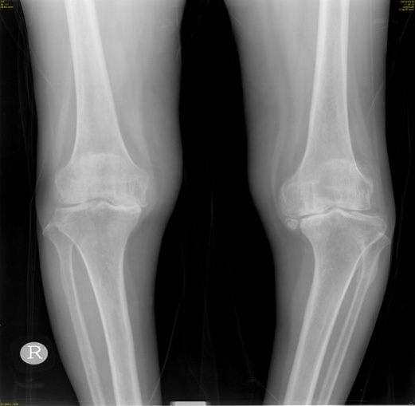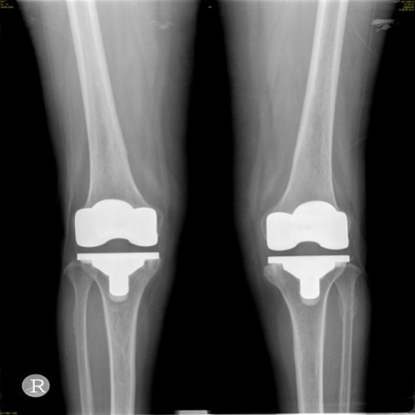

1C)
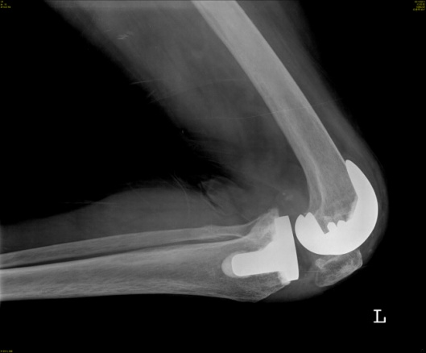

Results

As a result of radiologic assessments, Group A showed a 32.5 mm (9.0~52.5mm) preoperative medial deviation and 1.4 mm (-1.0~4.1mm) postoperative medial deviation (P=0.03), while Group B showed 34.3 mm (10.1~53.3 mm) preoperative medial deviation and 3.1 mm (-1.1~5.2 mm) postoperative medial deviation, indicating a statistically significant correction (P=0.04). No statistical significance was observed between the groups (P=0.14) (Table 1). The preoperative femur-tibia angle of Group A was significantly corrected from preoperative varus 4.1˚ (0.3°~7.9°) to postoperative valgus 6.7˚ (5.1°~8.1°) (P=0.01), and that in Group B was significantly corrected from preoperative varus 4.4˚ (0.1°~10.6°) to postoperative valgus 6.5˚ (5.5°~8.6°) (P=0.03). No statistical significance was observed between the groups (P=0.23) (Table 2). In Group A, the postoperative α, β, γ, and δ angles were 96.3˚, 90.7˚, 1.0˚, and 88.2˚, respectively; and in Group B, 96.9˚, 90.4˚, 1.6˚, and 89.5˚, respectively, showing no statistical significance between the groups (P=0.22 in α, 0.12 in β, 0.11 in γ, 0.07 in δ) (Table 3). In Group A there was 1 case (0.6%) in β angle, and 1 case (0.6%) in γ angle, which had more than 3.0˚ offset¹⁸⁾ in the postoperative prosthesis location compared with the guideline (α=96.0°, β=90.0°, γ=0.0°,δ=3.0°). In Group B, there were 3 cases (1.8%) in β angle, and 3 cases (1.8%) in γ angle. In one case (0.6%) of Group B, the mechanical axis deviation was 3 mm or more offset. In Group A, the patella-femur locations in the Merchant’s images based on the Bindelglass and Vinced¹⁷⁾ classification were: central, 101 cases (61.6%), lateral tilt, 63 cases (38.4%), and no medial tilt case. In Group B: central, 68 cases (41.5%), lateral tilt, 94 cases (57.3%), and no medial tilt case. No statistical significance was observed between the groups (P=0.14).
As a functional score, the mean HSS in Group A improved from preoperative 39.6 (25~73) to 93.8 (78~98) at the final follow-up (P=0.01), while those in Group B also improved from preoperative 41.4 (22~71) to 88.4 (76~90) at the follow-up (P=0.01) showing a statistical significance in both groups. No significant difference between the groups was observed (P=0.12). The mean KSS in Group A improved from preoperative 55.1 (10-58) to 93.4 (62-98) at the follow-up (P=0.03), while those in Group B also improved from preoperative 55.6 (11~59) to 90.8 (61~92) at the follow-up (P=0.01) showing a statistical significance in both groups. No significant difference between the groups was observed (P=0.09). The flexion contracture of Group A was preoperative 10.3˚ (0~30) and postoperative 4.0˚ (0~10) (P=0.03), while those of Group B were preoperative 13.1˚ (0~35) and postoperative 3.0˚ (0~13) (P=0.01) showing a statistical significance in both groups. No significant difference between the groups was observed (P=0.11). The ROM is the angle between the maximum joint extension and flexion, which a patient can actively move, and is measured with a goniometer. In Group A, the mean ROM increased from preoperative 106.4˚ (90~115) to 123.2˚ (110~130) at the final follow-up (P=0.01), while in Group B, those increased from preoperative 107.1˚ (95~116) to 123.0˚ (105~130) at the final follow-up (P=0.03) showing a statistical significance in both groups. No significant difference between the groups was observed (P=0.16) (Table 4). The number of cases that showed more than 130° maximum flexion angle at postoperative 4 weeks in Group A was 128 (78%), and 36 (22%) in Group B, showing a statistically significant difference between the groups (P=0.02). The mean tourniquet time during the surgery in Group A was 35 minutes (30-75), and that in Group B was 38 minutes (32-78). The mean incision length in Group A was 11.2 cm (9.8-14.2), and that in Group B was 11.1 cm (9.6-14.3). The mean blood loss in Group A was 414.2 cc (250-600), and that in Group B was 437.3 cc (260-620). With regard to complications, Group A reported one case of superficial infection but after marginal resection, the infection was removed at the final follow-up, and a 125˚ maximum flexion angle was obtained. In all cases of Groups A and B, no case of knee joint instability was observed in physical examinations and stress radiologic tests. No case of inexplicable loss of walking rhythm, and no anchylosis case with less than 90˚ ROM was reported.

Table 1. Comparison of mean MAD in Group A (Lospa) and Group B (Scorpio NRG).
 | Group A (LOSPA)  ^{(n=164)} | Group B (Scorpio NRG)  ^{(n=164)} | P-values
Mean preop* MAD‡ | 32.5mm (9.0-52.5) | 34.3mm (10.1-53.3) | 0.12
Mean postop† MAD | 1.4mm (-1.0-4.1) | 3.1mm (-1.1-5.2) | 0.14
P-values | 0.03 | 0.04
*: preoperation
†: postoperation
‡: mechanical axis deviation

Table 2. Comparison of mean T-F angle in Group A (Lospa) and Group B (Scorpio NRG).
 | Group A (LOSPA)  ^{(n=164)} | Scorpio NRG (Group B)  ^{(n=164)} | P-values
Mean preop* T-F‡ angle | Varus 4.1° (0.3-7.9) | Varus 4.4° (0.1-10.6) | 0.18
Mean postop† T-F angle | Valgus 6.7° (5.1-8.1) | Valgus 6.5° (5.5-8.6) | 0.23
P-values | 0.01 | 0.03
*: preoperation
†: postoperation
‡: tibia-femoral angle

Table 3. Comparison of mean post-operative implant position in Group A (Lospa) and Group B (Scorpio NRG).
 | LOSPA  ^{(n=164)} | Scorpio NRG  ^{(n=164)} | P-values
Mean α angle | 96.3° (94-98) | 96.9° (95-99) | 0.22
Mean β angle | 90.7° (86-91) | 90.4° (91-93) | 0.12
Mean γ angle | 1.0° (0-4) | 1.6° (1-4) | 0.11
Mean σ angle | 88.2° (86-90) | 89.5° (86-91) | 0.07

Table 4. Comparison of mean HSS, KSS, average ROM in Group A (Lospa) and Group B (Scorpio NRG).
 | Group A (LOSPA)  ^{(n=164)} | Group B (Scorpio NRG)  ^{(n=164)} | P-values
Mean preop* HSS§ score | 39.6 (25-73) | 41.4 (22-71) | 0.17
Mean postop† HSS score | 93.8 (78-98) | 88.4 (76-90) | 0.12
Mean preop KSS¶ score | 55.1 (10-58) | 55.6 (11-59) | 0.12
Mean postop KSS score | 93.4 (62-98) | 90.8 (61-92) | 0.09
Average preop ROM* | 106.4° (90-115) | 107.1° (95-116) | 0.08
Average postop ROM | 123.2° (110-130) | 123.0° (105-130) | 0.16
*: preoperation
†: postoperation
‡: Hospital for special surgery
§: Knee society score
¶: ROM

Discussion

To improve ROM, the high-flexion artificial knee joint is designed with a reduced back side radius in the femoral prosthesis, an extended posterior condyle length, and an enlarged offset of the posterior condyle to increase the rollback and translation of the condyle. Theoretically, over 125 degrees knee joint flexion is possible.^{1,19)} Daily activities are known to be managed with knee joint flexion ranging from 100 degrees to 110 degrees, and the ROM of typical standard artificial joints has been reported to range from about 100 degrees to 110 degrees.^{2,3,20)} These days more and more young patients undergo artificial joint replacements, and senior patients are expected to have limitless social activities after the surgery. The cross-legs position and squatting are possible with about 110 to 130 degrees maximum knee joint flexion. Many surgeons recently have performed high-flexion total knee arthroplasty reportedly allowing a maximum flexion angle up to 130 degrees (Fig. 2A, Fig 2B).^{2,4,19,21,27)} Many studies reported no significant difference between standard artificial joints and high-flexion artificial joints, but some studies reported that the high-flexion artificial joints showed significant joint movements in the early stage without developing complications, like those of the standard artificial joints.^{3,6,7,8,9,13)} Nevertheless, the high-flexion artificial joints require additional posterior condyle bone resection, and these excessive bone resection was reported in previous studies to have caused an early dissociation of the artificial joints. In particular, the dissociation of the femoral prosthesis significantly develops during the intermediate-term follow-up due to the repeated high-flexion stress. ^{4,10,14)} In addition, bone preservation is challenging in cases of revision surgeries, and prosthesis survival is also significantly affected after the revision surgery. ¹¹⁾ LPS Flex® (Zimmer Inc.) which is one of the high-flexion artificial knee joints that we, the authors, used in this study requires up to 12.5 mm posterior condyle bone resection, and Scorpio NRG® (Stryker Inc.), another artificial knee joint used in this study requires 8.0 mm. Lospa (Corentec Inc.) that was also used in this study requires 10.0 mm posterior condyle bone resection, which is thought appropriate.^{22,23,24,25)} In typical artificial joints, the anterior-posterior length of the femur, and its width often do not match with the patient’s knee joints, particularly among Asian patients. In case of Lospa artificial knee joint, the discrepancy in size was rare, and further studies on this issue may be necessary. ^{26,27,28)} Moreover, Lospa artificial knee joint improved patellar tracking and enhanced the articular surface contact through the anatomical design of femoral prosthesis. Additionally, knee joint instability in the middle of flexion was minimized with the design of single-radius femoral prosthesis; thus, the movements such as walking, standing up, and sitting down look more natural with its use. ¹⁵⁾ In addition, polyethylene components were designed with double radius and hind-leg cut-off for high flexion allowing some degree of knee joint rotation with a fixed prosthesis, which enables the subjects to do the cross-legs position. The purpose of this study was to analyze and compare the early radiologic and clinical outcomes of the new prosthesis, which is new in the market, with those of typical ones whose functions and designs have already been known. Therefore, their intermediate- and long-term outcomes such as dissociation and abrasion could not be described. ^{23,24,29)} In other words, the purpose of this study was to prospectively find out the peri- and postoperative differences in the groups of Lospa and Scorpio®. The radiologic prosthesis locations in the Lospa group showed 96.3˚, 90.7˚, 1.0˚, and 88.2˚ postoperative α, β, γ, and δ angles, respectively, and no significant differences from the mean values suggested by Edwald, ³⁰⁾ and those in Scorpio® group were observed. The Scorpio NRG® artificial knee joint has not been reported to have shown significantly better results than other high-flexion artificial joints. However, the result of Scorpio NRG® artificial joint has been proven by many studies, so these comparisons may be meaningful. ^{12,23,24,29)} One-year follow-up may not be sufficient for comparing the ROM and maximum flexion angle, but within the extent that the patient conditions did not significantly change, the period might be long enough for assessing the efficiency of the artificial joints. The mean maximum flexion angle in Lospa group significantly increased from preoperative 106.4˚ (90°~115°) to 123.2˚ (110°~130°) at the final follow-up, and the angle reached even up to 130 degrees, thus the design is considered advantageous for high flexion. This result is similar to or better than those in the Scorpio® group: preoperative mean of 107.1˚ (95°~116°) to follow-up mean of 123.0˚ (105°~130°). In particular, the Lospa group reported 128 (78%) cases of 130˚ or greater maximum flexion angle at postoperative 4 weeks, showing a better early recovery of joint movements than that in the Scorpio® group that reported 36 (22%) cases under the same condition. This implies that Lospa artificial knee joint is a more favorable design for early joint movements than Scorpio.® In this study, no statistically significant difference in radiologic and clinical results were observed between the Lospa group and the Scorpio® group. In the Lospa group, a greater frequency of the central of the patella was observed in the axial patella-femur photos. The patella-femur locations in the Merchant’s images based on the Bindelglass and Vinced classification were 101 central cases in Group A, and 68 cases in Group B, showing no significant difference between the groups. In the Lospa group, the patella-femur joint was less sensitive to patellar tracking, and this may be the factor that could reduce the patella subluxation that may occur when the prosthesis is inserted into an inappropriate location. Considering similar operation time and the postoperative amount of bleeding between the groups, other surgical conditions may be expected to be the same. The limitations of this study include the very short follow-up period for assessing the performance of the artificial joints, and the limited number of samples to expect accurate results. In addition, problems that may develop on a long-term basis, such as the dissociation, abrasion, instability, and long-term survival rate of the artificial joints could not be investigated in this study. Despite these limitations, the early outcomes of the newly introduced artificial joints were prospectively compared with those of the typical prostheses, and these are considered meaningful.

Figures 2A, 2B. A 74-year-old female underwent Lospa total knee arthroplasty and was able to do cross-legs position and squatting without pain.

2A) 2B)
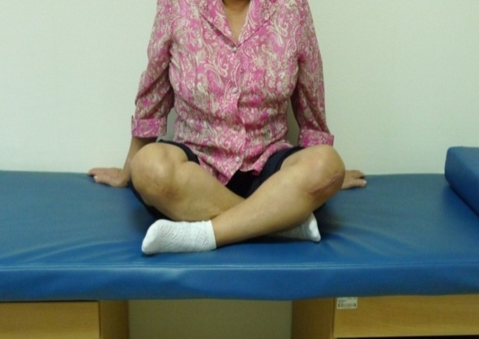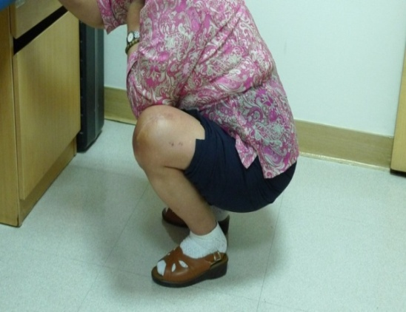

Conclusion

In this study, total knee arthroplasty was performed by a single surgeon using Scorpio NRG® and Lospa, which was designed with high flexion and single radius. Their radiologic and clinical results were compared. No statistically significant radiologic and clinical differences were observed between the groups. Both groups showed excellent early radiologic and clinical outcomes, but the Lospa group showed more favorable results in obtaining the maximum flexion angle at the early follow-up, and in maintaining the patella-femur joint. In future studies, investigations on the survival rate of prostheses, and intermediate- and long-term monitoring of clinical and radiologic results using more samples may be necessary.
References

- Kim YH, Sohn KS, Kim JS. Range of motion of standard and high-flexion posterior stabilized total knee prosthesis. A prospective, randomized study, J Bone Joint Surg Am. 2005;87:1470-7.
- S. Endres and A. Wilke. High flexion total knee arthroplasty –midterm follow up of 5 Years, The Open Orthopaedics Journal. 2011;5:138-42.
- Stefan Endres. High-flexion versus conventional total knee arthroplasty: a 5-year study, J orthop surgery. 2011;19 (2):226-9.
- Zelle J, Janssen D, Van Eihden J, De Waal Malefijt M, Verdonschot N. Does high-flexion total knee arthroplasty promote early loosening of the femoral prosthesis?, 2011;29 (7):976-83.
- Massin P, Dupuy FR, Khlifi H, Fornasieri C, De Polignac T, Schifrine P, Farenq C, Merti P. Does hyperflex total knee design improve postoperative active flexion?, 2010;96 (4):376-80.
- Bin SI, Nam TS. Early results of high-flexion total knee arthroplasty: comparison study at 1 year after surgery, Knee Surg Sports Traumatol Arthrosc. 2007;15 (4):350-5.
- Huang HT, Su JY, Wang GJ. The early results of high-flexion total knee arthroplasty: minimum of 2 years of follow-up, J Arthroplasty, 2005;20 (5):674-9.
- Song EK, Park SJ, Yoon TR, Park KS, Seo HY, Seon JK. Hi-flexion and gender-specific designs fail to provide significant increases in ROM during cruciate-retaining total knee arthroplasty, J Arthroplasty. 2012;27 (6):1081-4.
- Kim YH, Park JW, Kim JS. High-flexion total knee arthroplasty: survivorship and prevalence of osteolysis: results after a minimum of ten years of follow-up, J Bone Joint Surg Am. 2012;94 (15):1378-84.
- Hyuk-Soo Han MD, PhD, Seung-Baik Kang MD, PhD. Brief follow-up report, Does high-flexion total knee arthroplasty allow deep flexion safely in Asian patients?, Clin Orthop Relat Res. 2012; (28):1007-1013.
- Bauman RD, Johnson DR, Menge TJ, Kim RH, Dennis DA. Can a high-flexion total knee arthroplasty relieve pain and restore function without premature failure?, Clin Orthop Relat Res. 2012;470 (1):150-8.
- Long WJ, Scuderi GR. High-flexion total knee arthroplasty, J Arthroplasty. 2008;23 (7):6-10.
- Zhang Y, Liu J, Tian MQ, Cheng Y, Tian ZW, Sun ZH, Ma XL. Effect of posterior condylar offset on knee flexion after high-flex posterior-stabilized total knee arthroplasty, Zhonghua Wai Ke Za Zhi. 2010;48 (10):764-8.
- Bollars P, Luyckx JP, innocent B, Labey L, Victor J, Bellemans J. Femoral prosthesis loosening in high-flexion total knee replacement: an in vitro comparison of high-flexion versus conventional designs, J Bone Joint Surg Br. 2011;93 (10):1355-61.
- Borrione F, Bonnevialle P, Mabit C, Guingand O, Bertin D Bonnomet F, Denis C, Gagna G. Scorpio single radius total knee arthroplasty. A minimal five-year follow-up muticentric study, Int Orthop. 2011;35 (12):1777-82.
- Kellgren JH, Lawrence JS. Radiological assessment of osteoarthritis, Ann Rheum Dis. 1957;16:494-501.
- Bindelglass DF, Vince KG. Patellar tilt and subluxation following subvastus and parapatellar approach in total knee arthroplasty. Implication for surgical technique, J Arthroplasty. 1996;11 (5):507-11.
- Jong-Keun Seon, M.D., Eun Kyoo Song, M.D. The Accuracy of Lower Extremity Alignment in a Total Knee Arthroplasty Using Computer-Assisted Navigation System, J Korean Orthop Assoc. 2004;39:566-71.
- Meneghini RM, Pierson JL, Bagsby D, Ziemba-Davis M, Berend ME Ritter MA. Is there a functional benefit to obtaining high-flexion after total knee arthroplasty?, J Arthroplasty. 2007;22 (6):43-6.
- Anna K Nilsdotter, Soren Toksvig-Larsen, and Ewa M Roos. Knee arthroplasty: are patients’ expectations fulfilled? A prospective study of pain and function in 102 patients with 5-year follow-up, Acta Orthopaedica. 2009;80 (1):55-61.
- Deyers BN, Conditt MA, Jamiesson ML, Driscoll MD, Noble PC, Parsley BS. Does greater knee flexion increase patient function and satisfaction after total knee arthroplasty?, J Arthroplasty. 2011;26 (2)178-86.
- Kwang-Hwan Jung, M.D., Sung-Do Cho, M.D., Sang-Hun Go, M.D., Jae-Ryong Cha, M.D., Chae-Chil Lee, M.D., Yoon-Seok Youm, M.D., and Ki-Bong Park, M.D. Total knee Arthroplasty with NexGen System – 3-8 Year Follow-up Results, J Korean Orthop Assoc. 2007;42:730-36.
- Akasaki Y, Matsuda S, Shimoto T, Miura H, Higaki H, iwamoto Y. Contact stress analysis of the conforming post-cam mechanism in posterior-stabilized total knee arthroplasty, J Arthoplasty. 2008;23 (5):736-43.
- Abbas D, Gunn RS. Medium-term results of the scorpio total knee replacement, Knee. 2006;13 (4):307-11.
- Kim YH, Park JK, Kim JS. High-flexion total knee arthroplasty: survivorship and prevalence of osteolysis: results after a minimum of ten years of follow-up, J Bone Joint Surg Am. 2012;94 (15):1478-84.
- Eggers MD, Brewer KE, Fang L, Lionberger DR. Improved knee flexion following high-flexion total knee arthroplasty, J Orthop surg Res. 2012;7 (1):22.
- Thomsen MG, Husted H, Bencke J, Curtis D, Holm G, Troelsen A. Do we need a gender-specific total knee replacement? A randomized controlled trial comparing a high-flexion a gender-specific posterior design, J Bone Joint Surg Br. 2012;94 (6):787-92.
- Jia YT, Wang L, Zhang Y, Zhao C, Sun ZH, Liu J. Does mismatch of the femoral prosthesis aspect ratio influence the range of knee flexion after posterior-stabilized total knee arthroplasty?, Chin J Traumatol. 2012;15 (3):152-7.
- Hamai S, Mirua H, Matsuda S, Shimoto T, Higaki H, IWamoto Y. Contact stress at the anterior aspect of the tibial post in posterior-stabilized total knee replacement, J Bone Joint Surg Am. 2010;92 (8);1765-73.
- Ewald FC. The knee society total knee arthroplasty roentgenoevaluation and scoring system, Clin Orthop Relat Res. 1989;248:9-12.

